ASSIGNMENT 30

Name : Akanksha Joshi

Roll No : B038

Batch : 3

Div : BTech CS B

--------------------------------------------------------------------------------------------------------------------------

Q.Write a Python program to implement the following (Use Recursion):

1.Print ﬁrst 'n' multiples of 3, where 'n' is taken as an input from the user. The multiples should be printed from ﬁrst to last.

2.Reverse a string. Print the original and reversed string.

3.Check if the given string is palindrome. If yes, print "String is palindrome" otherwise print "String is not palindrome".

1.

Source Code

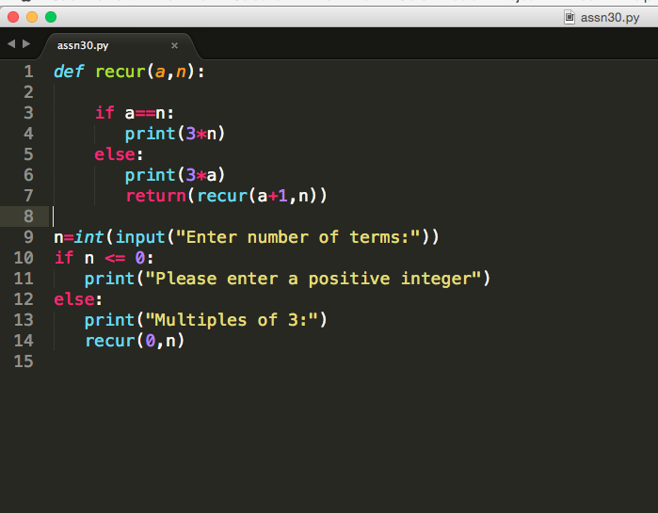

Output

Enter number of terms:21  
Multiples of 3:  
0  
3  
6  
9  
12  
15  
18  
21  
24  
27  
30  
33  
36  
39  
42  
45  
48  
51  
54  
57  
60  
63

2.

Source Code

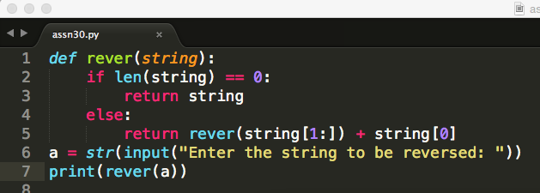

Output

Enter the string to be reversed: akanksha

ahsknaka

3.

Source Code

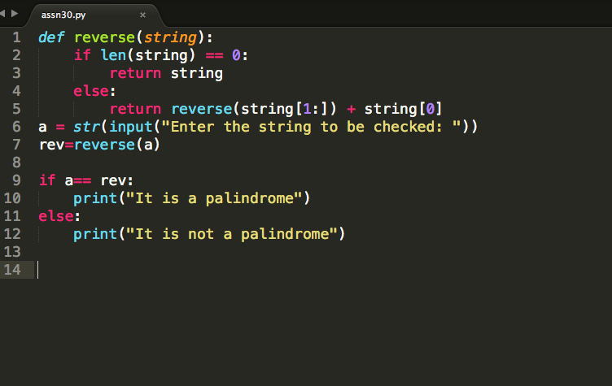

Output

1. When not a palindrome

Enter the string to be checked: joshi

It is not a palindrome

B. When it is a palindrome

Enter the string to be checked: level

It is a palindrome